## Front End Engineering-II

Project Report

Semester-IV (Batch-2022)

Title of the Project: Trip Finder



**Supervised By: Submitted By:**

Raveesh Samkaria Name: Suraj Adde

Roll no: 2210990876

Group: G-13

**Department of Computer Science and Engineering**

## Chitkara University Institute of Engineering & Technology,

## Chitkara University, Punjab

**CONTENTS:**

|  |  |  |  |
| --- | --- | --- | --- |
| **S.NO** | **CONTENT** | | **PAGE.NO** |
| **1** | **Introduction** | | **3-5** |
| **3** | **Problem Definition and Requirements** | | **6-9** |
| **4** | **Technical Details** | | **10-12** |
| **5** | **File Structure** | | **13-14** |
| **6** | **Proposed Design/Methodology** | | **15-17** |
| **7** | **Source Code** | | **18-25** |
| **8**  **9** | **Result**  **Reference** | **25-28**  **29** | |

**Introduction:**

Welcome to our Travel and Events web application, a platform designed to provide users with detailed information about various promotional trips and the latest news and events in the travel industry. This application aims to offer a seamless and visually appealing user experience by combining modern web design with comprehensive travel information.

**Background:**

This Travel and Events web application was created to bridge the gap between travel enthusiasts and the latest offerings in the travel industry. The platform showcases a range of promotional trips, complete with vivid images and essential details, enabling users to explore travel opportunities easily. Additionally, it features a news and events section that provides timely updates on the latest happenings in the travel world. Built using React, the application employs modern web design principles to ensure a responsive and aesthetically pleasing user experience across devices. By integrating comprehensive travel insights with current news, this project aims to cater to both casual travelers and industry professionals, offering an intuitive and informative interface.

**Objective:**

**Objectives of the Travel and Events Web Application**

**1. Showcase Promotional Trips:**

**- Display a curated selection of travel packages with high-quality images and key details to attract potential travelers.**

**2. Provide Latest Travel News:**

**- Offer up-to-date information on travel-related news and events to keep users informed about industry trends and developments.**

**3. Enhance User Experience:**

**- Ensure a seamless and engaging user experience through intuitive navigation, responsive design, and visually appealing layouts.**

**4. Integrate Modern Technologies:**

**- Utilize React and modern CSS techniques to build a dynamic and responsive web application.**

**5. Facilitate Easy Access to Information:**

**- Organize content in a well-structured manner, allowing users to easily find and explore promotional trips and news articles.**

**6. Promote Travel Enthusiasm:**

**- Inspire and motivate users to explore new travel destinations and stay connected with the latest travel industry updates.**

**7. Maintain Consistent Branding:**

**- Use consistent design elements and styling to create a cohesive and professional appearance throughout the application.**

**8. Support Multiple Devices:**

**- Ensure the application is fully responsive and functions well on various devices, including desktops, tablets, and smartphones.**

**Significance:**

**The Travel and Events web application is a pivotal innovation designed to revolutionize the way users plan and stay informed about their travel adventures. This platform significantly enhances the travel planning experience by providing detailed, visually appealing information on a variety of promotional trips, complete with high-quality images and essential details. It serves as a comprehensive hub for the latest news and events in the travel industry, keeping users well-informed about current trends, important announcements, and emerging destinations. By employing modern web technologies such as React and CSS, the application ensures a seamless, responsive, and engaging user experience, whether accessed on desktops, tablets, or smartphones. This responsiveness and intuitive design promote deeper user engagement, encouraging exploration of the diverse travel opportunities presented.**

**Moreover, the platform plays a crucial role in promoting various travel destinations and packages, potentially boosting tourism and supporting the travel industry by connecting businesses with enthusiastic travelers. It acts as an educational resource, offering insights into travel trends and industry news, making it valuable for both travel enthusiasts and professionals. The economic impact of this application is notable, as it facilitates easier access to travel information and promotions, driving more frequent travel and increased spending on travel-related services. Additionally, by sharing news, events, and experiences, the platform fosters a sense of community among travelers, enhancing the social aspects of travel and tourism. This holistic approach not only benefits individual travelers by simplifying their planning process but also contributes to the broader travel ecosystem, promoting growth and innovation within the industry.**

**Problem Definition and Requirements**

In today's fast-paced world, travelers often face challenges in finding reliable, up-to-date information on promotional travel packages and industry news. The fragmentation of travel information across various platforms makes it difficult for users to make informed decisions efficiently. Additionally, the lack of a centralized, visually appealing, and user-friendly interface further complicates the travel planning process. This leads to missed opportunities for both travelers seeking the best deals and travel businesses aiming to connect with potential customers. Therefore, there is a need for a unified platform that consolidates promotional trip information and current travel news while providing an intuitive, engaging user experience.

**Problem Statement:**

Design and develop a responsive web application for a travel and tours company. The goal is to create a user-friendly platform that allows visitors to explore various travel destinations, view tour packages, book deals, and stay updated with news and events. The website should have the following key features:

**1. Navigation and Header:**

- A navbar with links to Home, Blog, Gallery, Activities, Deals, and Contact pages.

- Contact information (phone, email, hours of operation) displayed prominently.

- Social media icons for easy access to social profiles.

**2. Hero Section:**

- A visually appealing hero section introducing the website's main message and search functionality for tours.

- Engaging content inviting users to discover their next adventure.

**3. Tour Types Section:**

- Showcase different tour types (e.g., North America, Switzerland, San Francisco, Amazon Cruise) with images and descriptions.

- Each tour type should be clickable, leading to more details about the specific tour.

**4. Deals and Discounts Section:**

- Highlight special deals and discounts on tours with images, pricing information, and booking options.

- Include a "Book Now" button for each deal.

**5. Promotional Trips Section:**

- Showcase promotional trips with images, trip details, and discounted pricing.

- Provide information about the destination, duration, and inclusions of each trip.

**6. News and Events Section:**

- Display the latest news and events related to travel, including articles, announcements, and upcoming tours.

- Each news/event item should have a title, date, author/admin name, and a brief description.

**7. Footer:**

- Support section with FAQs, payment options, and booking tips.

- Social media links (Facebook, Twitter, Instagram, YouTube) for users to follow.

- Newsletter subscription form allowing users to receive updates and promotions via email.

**8. Overall Design and Responsiveness:**

- Ensure the website is visually appealing, user-friendly, and responsive across devices (desktop, tablet, mobile).

- Use appropriate styling, colors, fonts, and images to create an engaging travel experience.

**Software Requirements:**

1. Web Development Framework: Choose a suitable framework for web development, such as React.js to build a dynamic and responsive website.

2. Content Management System (CMS): Implement a CMS like WordPress or Drupal to manage and update website content efficiently, including menus, images, and promotional materials.

3. Database Management System (DBMS): Utilize a DBMS like MySQL, MongoDB, or PostgreSQL to store and manage user data, reservations, orders, and other relevant information securely.

4. Frontend Technologies: Employ HTML, CSS, and JavaScript along with any necessary libraries or frameworks to create an intuitive and visually appealing user interface.

**Hardware Requirements:**

1. Web Server: Deploy the website on a reliable web hosting server capable of handling expected traffic volumes and ensuring optimal performance and uptime.

2. Development Environment: Set up development workstations with adequate processing power, memory, and storage capacity to facilitate smooth software development and testing processes.

3. Networking Infrastructure: Ensure a stable internet connection and network infrastructure to support seamless communication between server-side and client-side components.

**Technical Details:**

Certainly! Here are the technical details for your React project based on the problem statement provided:

**1. Front-End Framework: React.js**

- Use React for building the user interface and creating reusable components.

- Leverage React's virtual DOM for efficient rendering and updating of UI elements.

- Utilize React Router for implementing routing and navigation between different pages/components.

**2. Styling:**

- Use CSS (Cascading Style Sheets) for basic styling.

- Consider using a CSS framework like Tailwind CSS for rapid development and responsive design.

- Implement responsive design principles to ensure the website looks good and functions well on various devices (desktop, tablet, mobile).

**3. Images and Assets:**

- Organize image assets (e.g., tour images, icons, backgrounds) in the project directory.

- Use image optimization techniques to improve website performance and loading times.

**4. Component Structure:**

- Create modular and reusable components for different sections of the website (e.g., Navbar, Hero, Tour Types, Deals, News, Footer).

- Break down the UI into smaller components for easier maintenance and scalability.

- Implement props and state management as needed to pass data between components.

**5. Data Management:**

- For static data (e.g., tour types, deals, news), store information directly in the components or import from JSON files.

- Use mock data or placeholder content where actual content is not available.

- Consider integrating with a backend API for dynamic content management if required in the future.

**6. UI/UX Design:**

- Design the user interface (UI) with a focus on user experience (UX) principles.

- Ensure intuitive navigation, clear call-to-action buttons, and visually appealing layouts.

- Use consistent styling, colors, typography, and spacing throughout the website for a cohesive look.

**7. Testing and Debugging:**

- Test the website across different browsers (Chrome, Firefox, Safari) and devices (desktop, tablet, mobile) to ensure compatibility and responsiveness.

- Perform unit testing for critical components and functionality.

- Use browser developer tools and debugging techniques to identify and fix any issues.

**8. Deployment:**

- Host the React application on a web hosting service or deploy to a cloud platform (e.g., Netlify, Vercel, AWS, Firebase).

- Configure deployment settings and domain/subdomain as per your project requirements.

**9. Documentation:**

- Create a README.md file with project details, setup instructions, dependencies, and other relevant information.

- Document the component structure, data flow, and any additional notes for future reference or collaboration.

**10. Version Control:**

- Use Git for version control and collaborate with team members if applicable.

- Maintain a Git repository with regular commits, branches for feature development, and pull requests for code review.

**File Structure:**

Here's a brief description of each folder and file:

**1. public/:** This folder contains the `index.html` file and other static assets that are publicly accessible. You can place favicon.ico, robots.txt, and other similar files here.

**2. src/:** This is the main source folder where your React application code resides.

- assets/: Contains all the images and other static assets used in your application.

- components/: This folder contains all your React components organized into separate files.

- App.js: The main component where your application is initialized and routes are defined.

- index.js: The entry point for your React application where ReactDOM renders the App component into the root HTML element.

- styles.css: Global CSS styles for your application.

**3. .gitignore:** Configuration file for Git to specify which files and directories to ignore in version control (e.g., node_modules, build folders).

**4. package.json:** Configuration file for npm (Node Package Manager) that includes project dependencies, scripts, and metadata.

**5. README.md:** Documentation file with project information, setup instructions, and other relevant details.

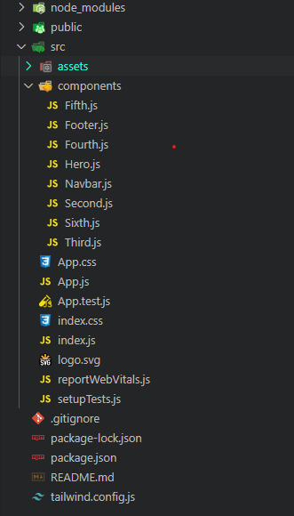 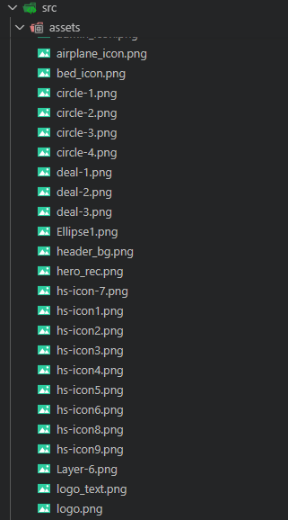

**Proposed Design / Methodology** 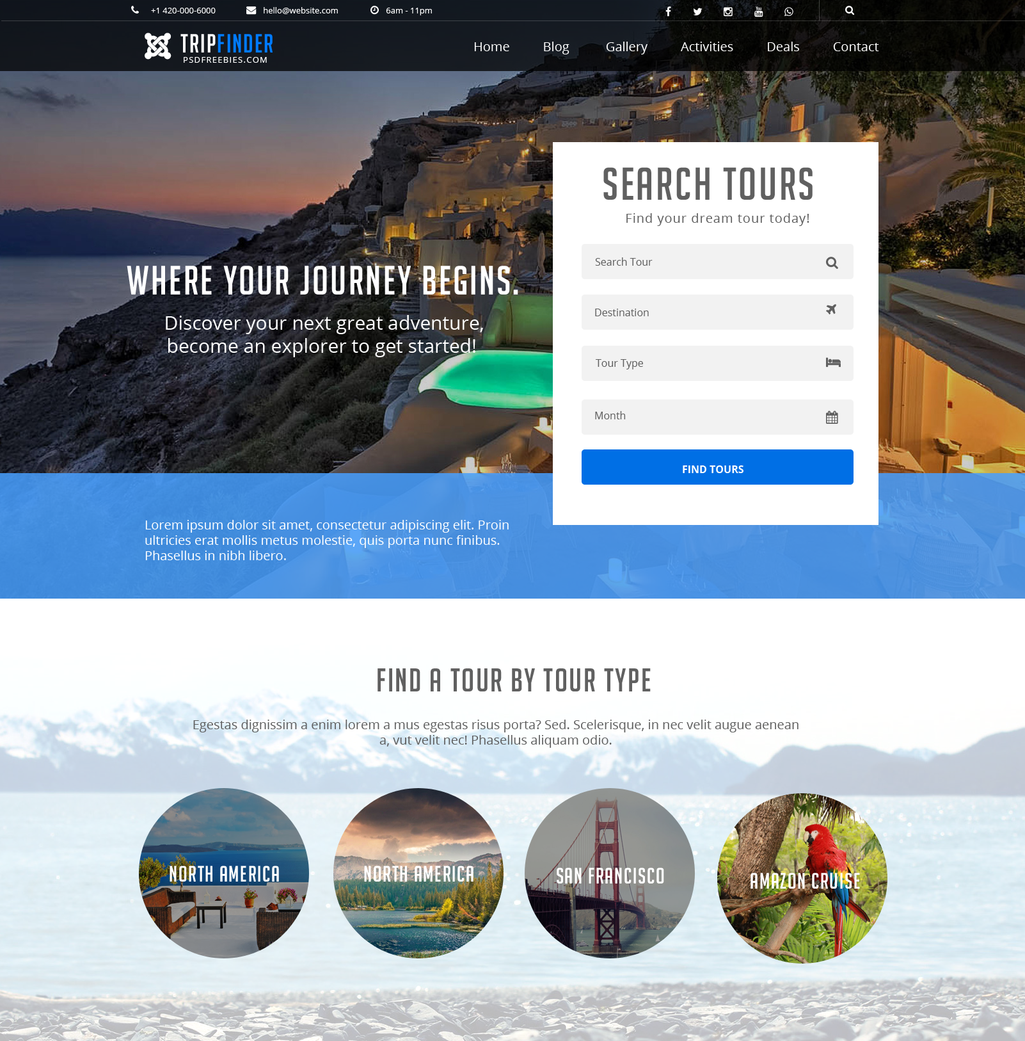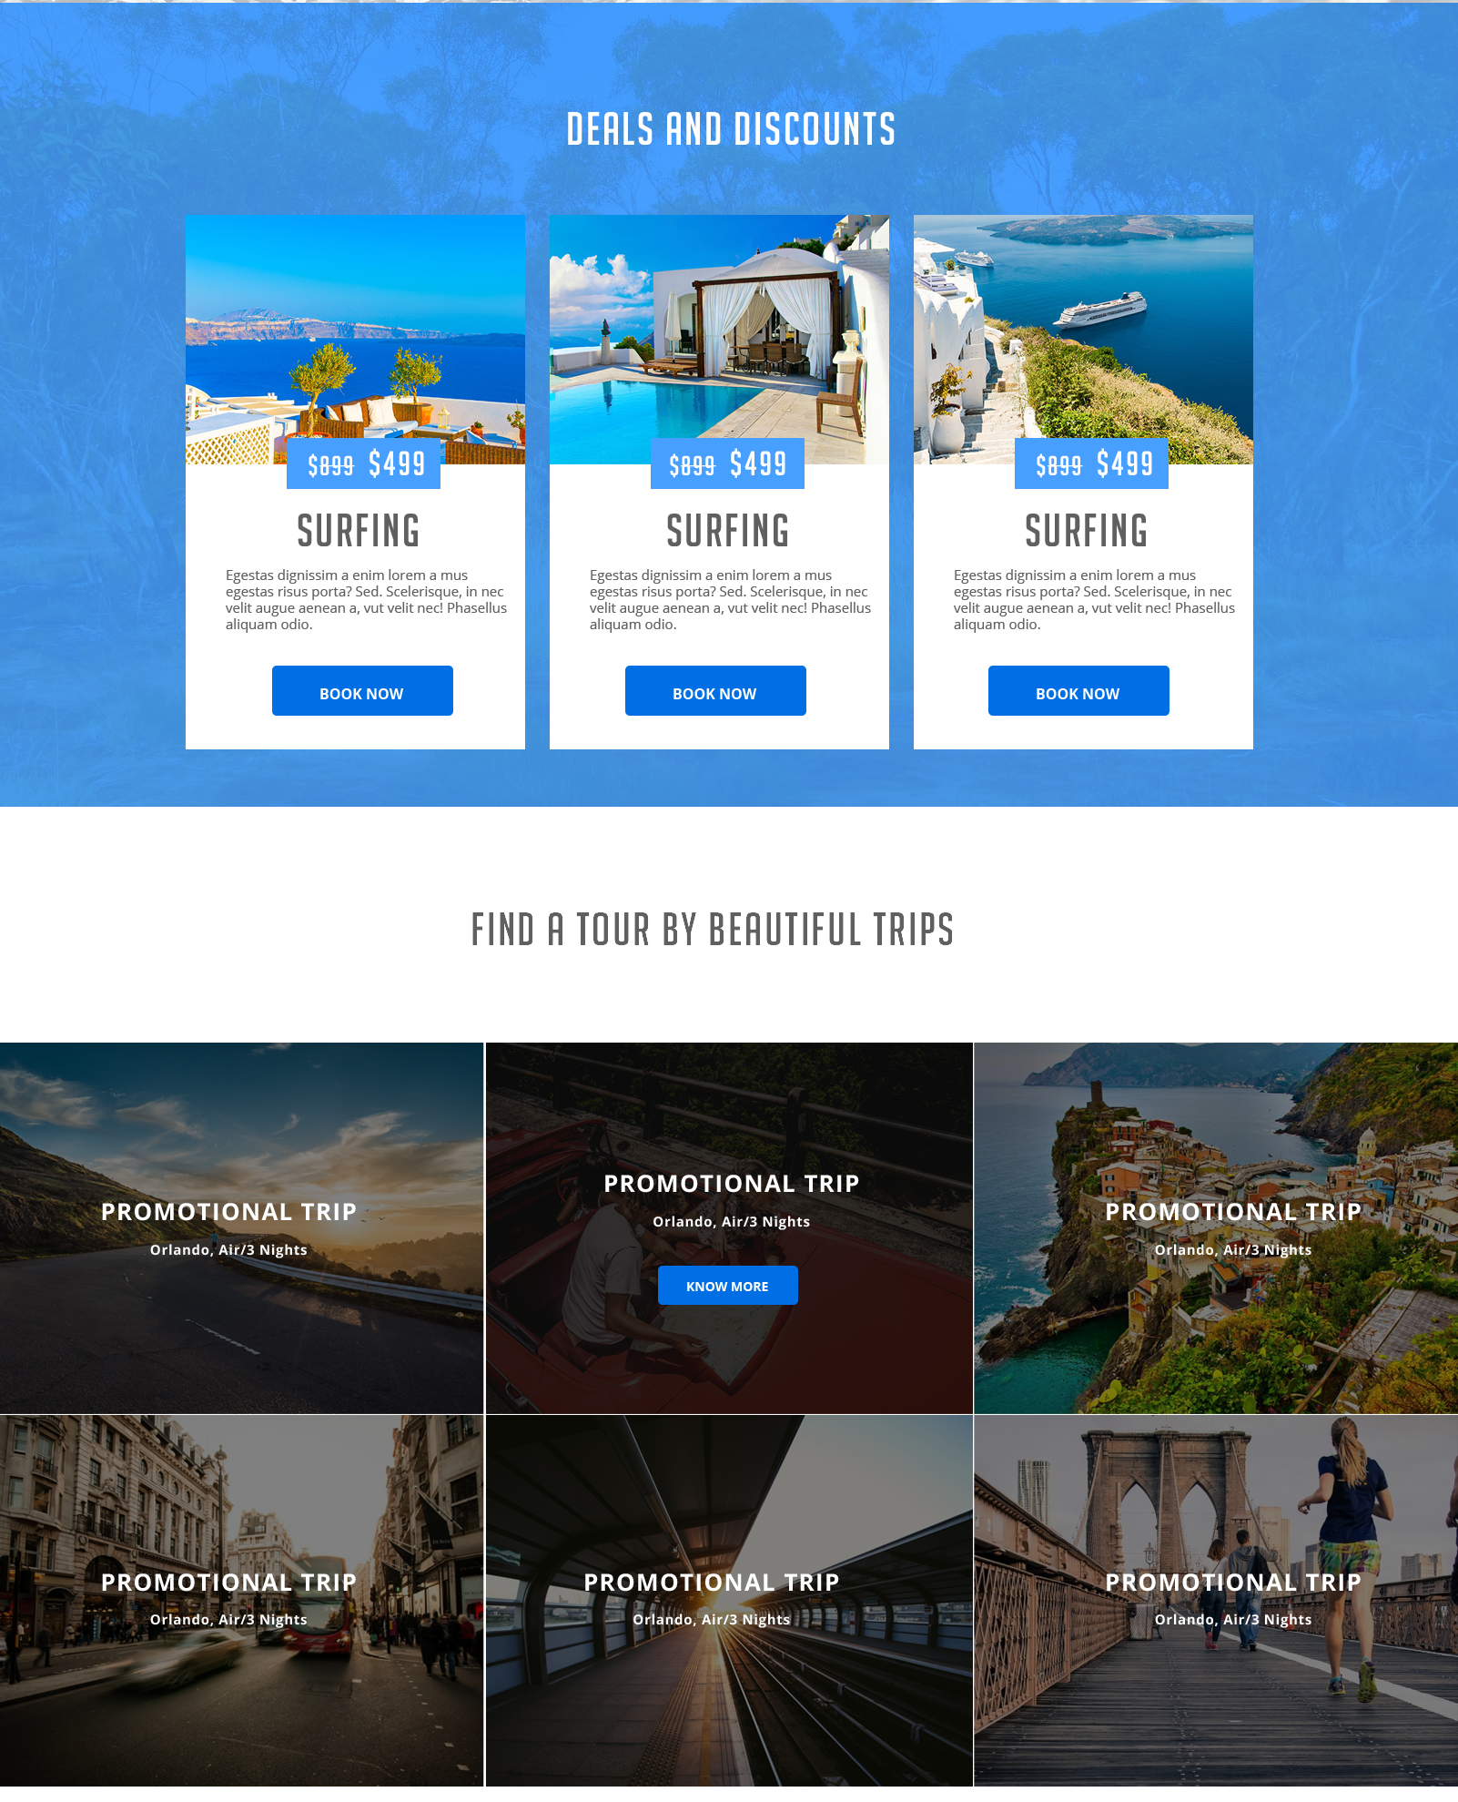

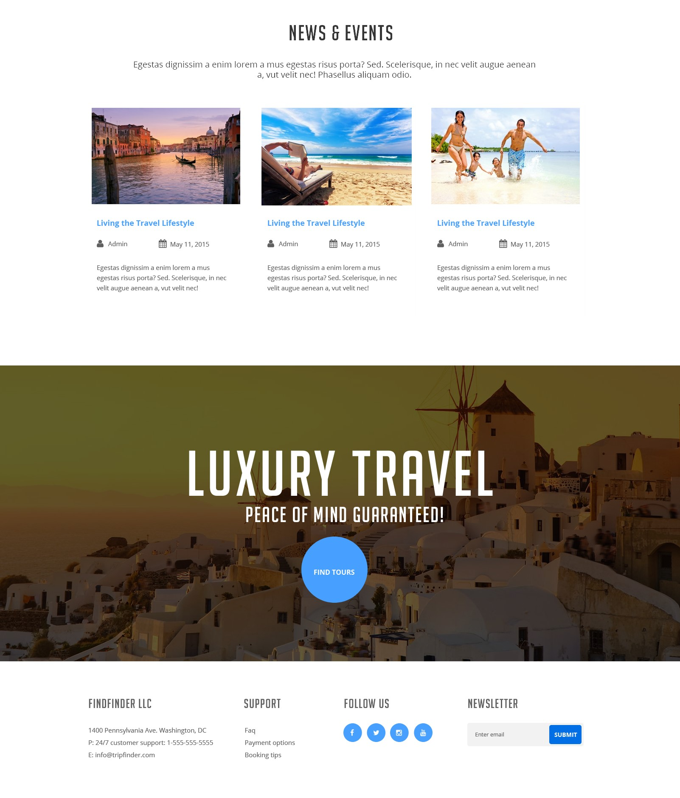

**Source code:**

**App.js:**

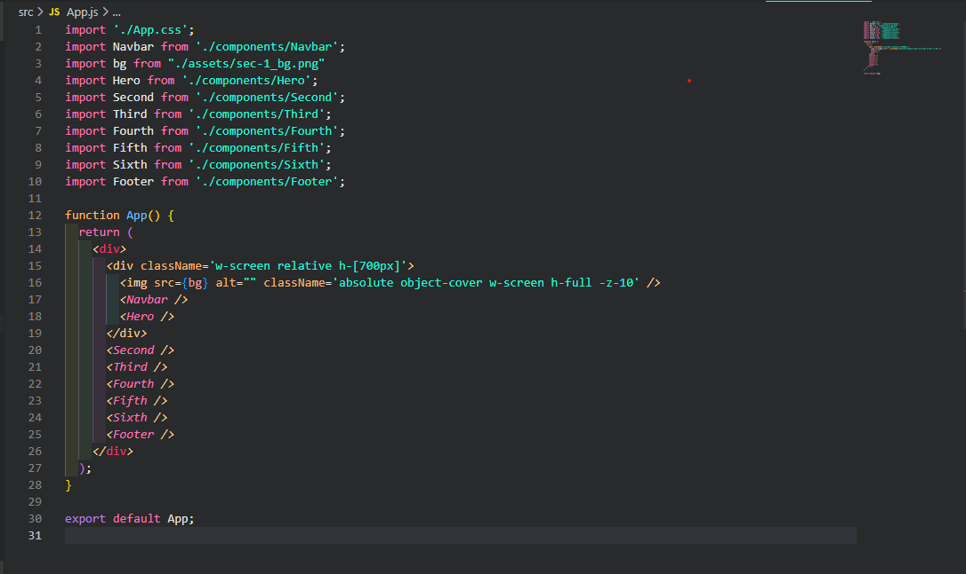

**Navbar.js:**

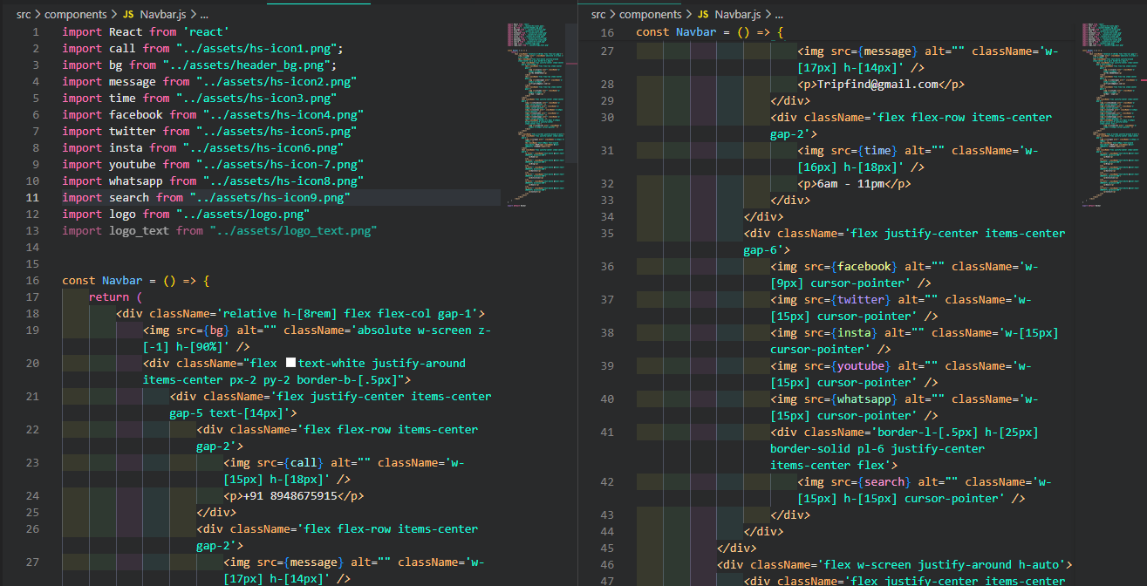

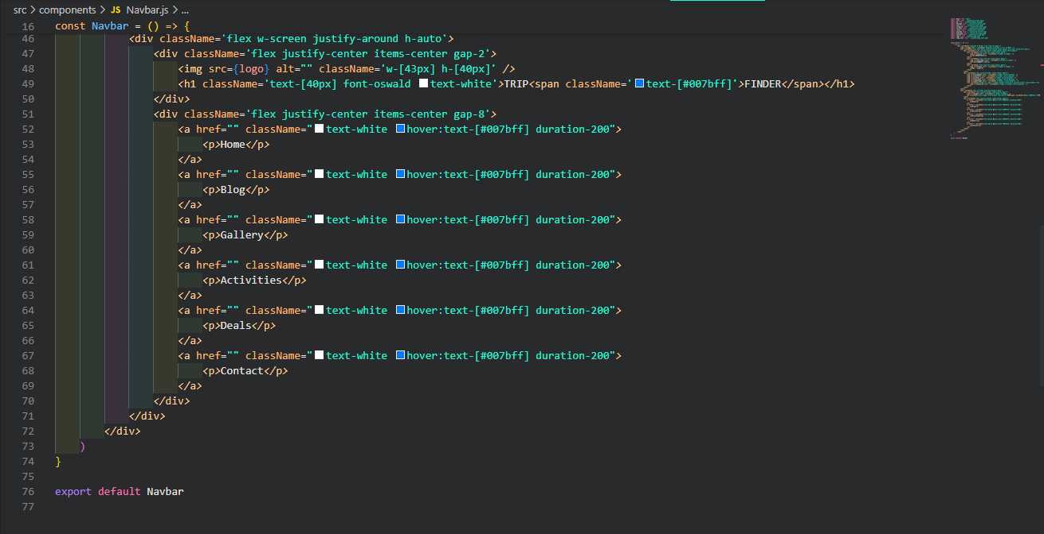

**Hero.js:**

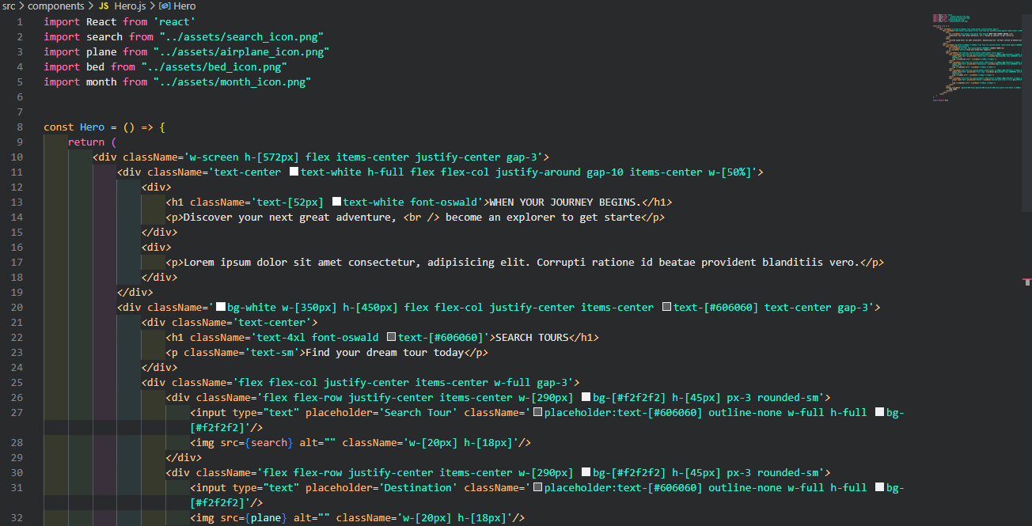

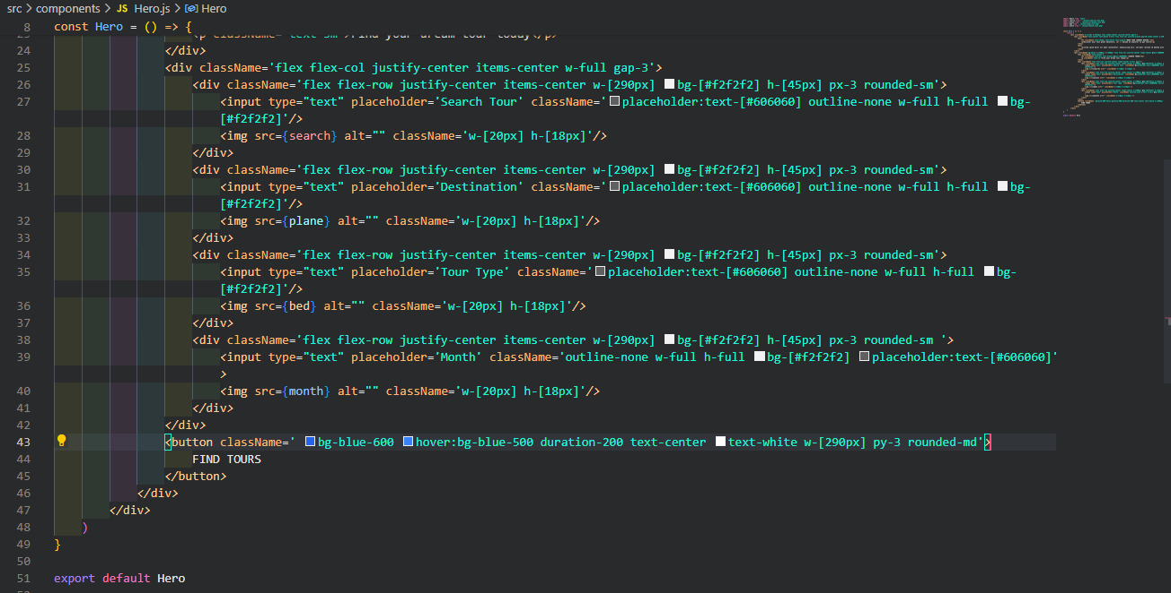

**Second.js:**

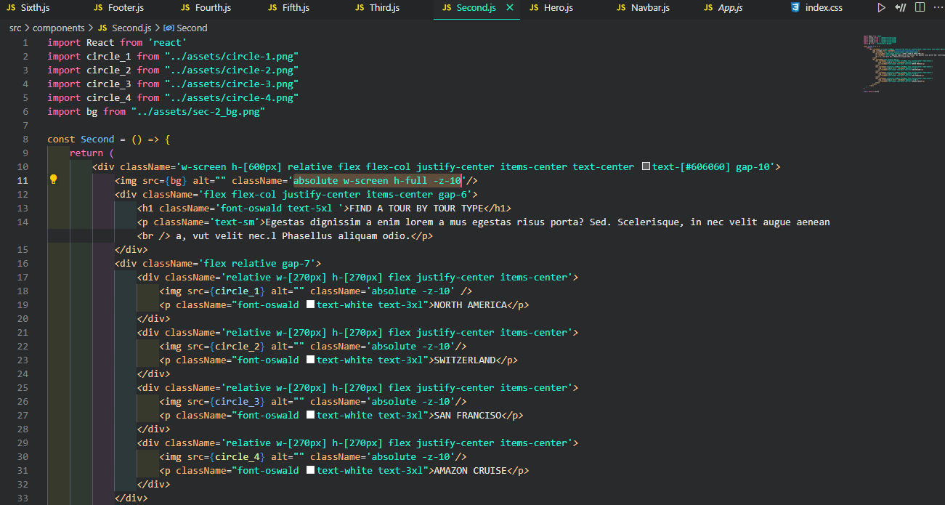

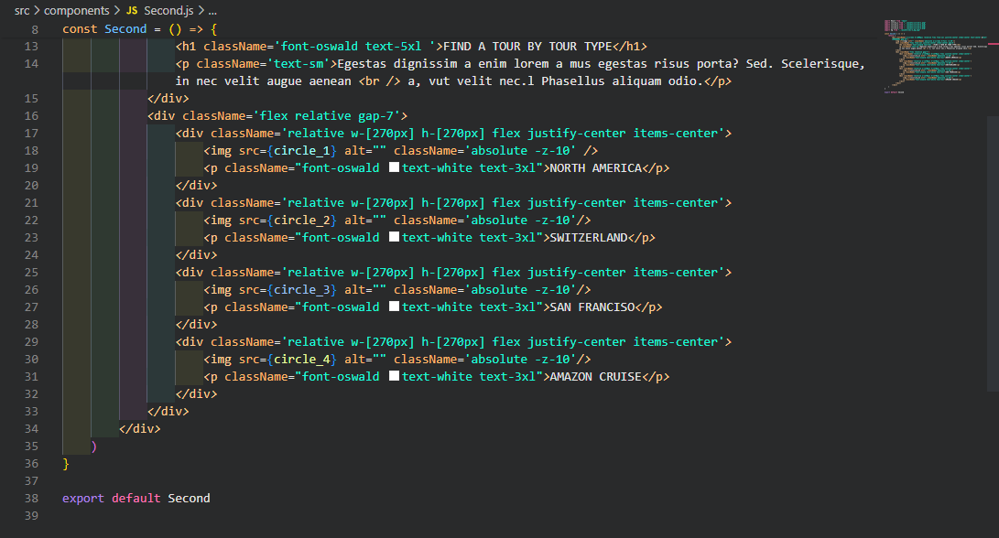

**Third.js:**

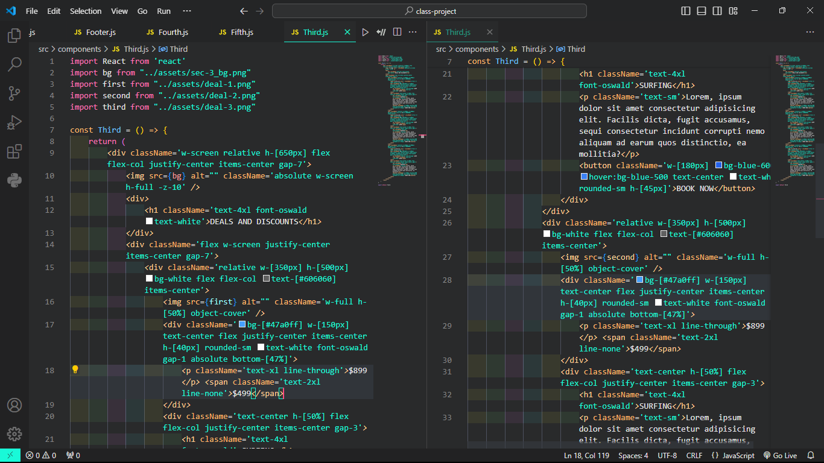

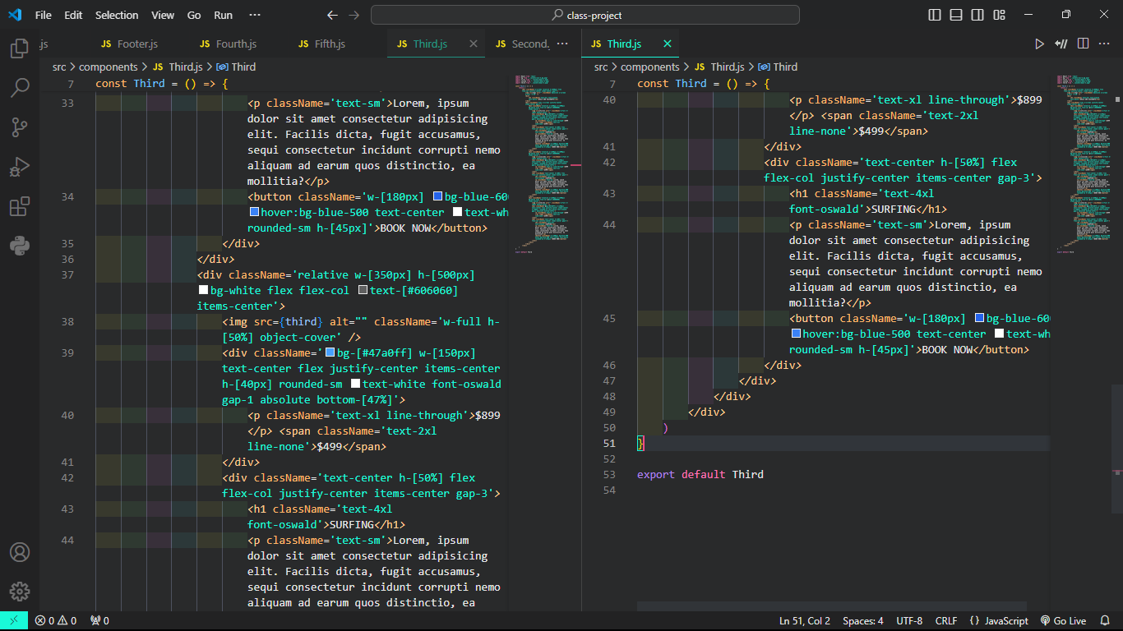

**Fourth.js:**

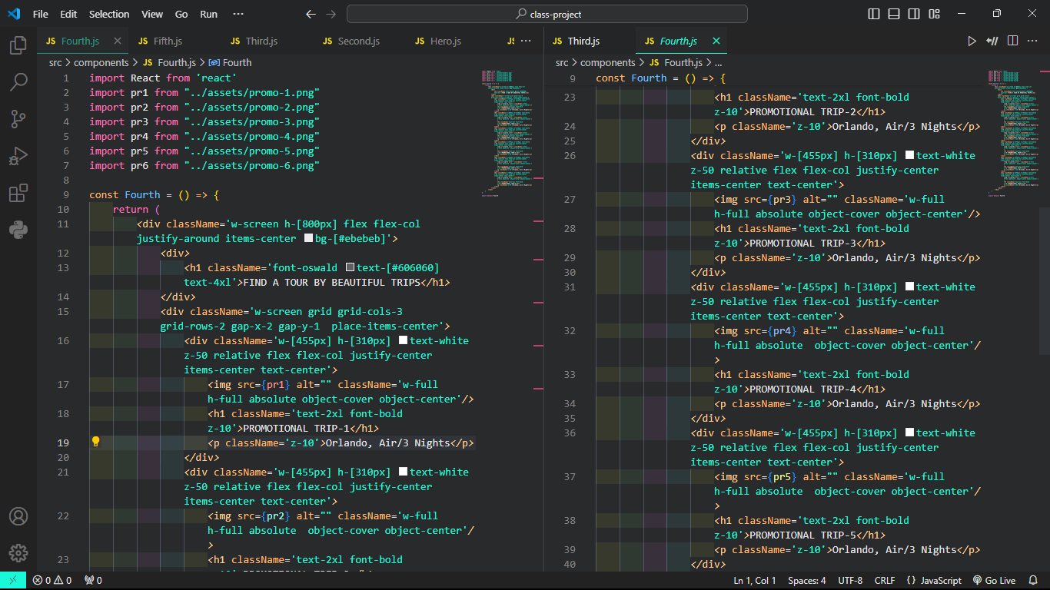

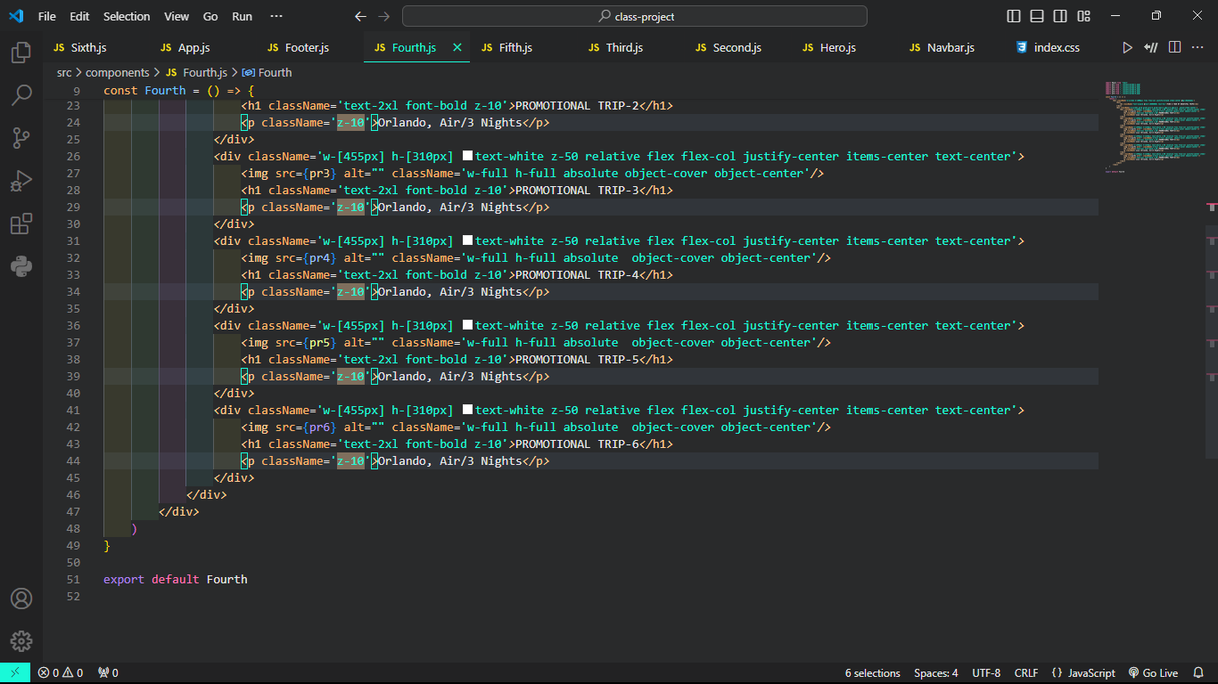

**Fifth.js:**

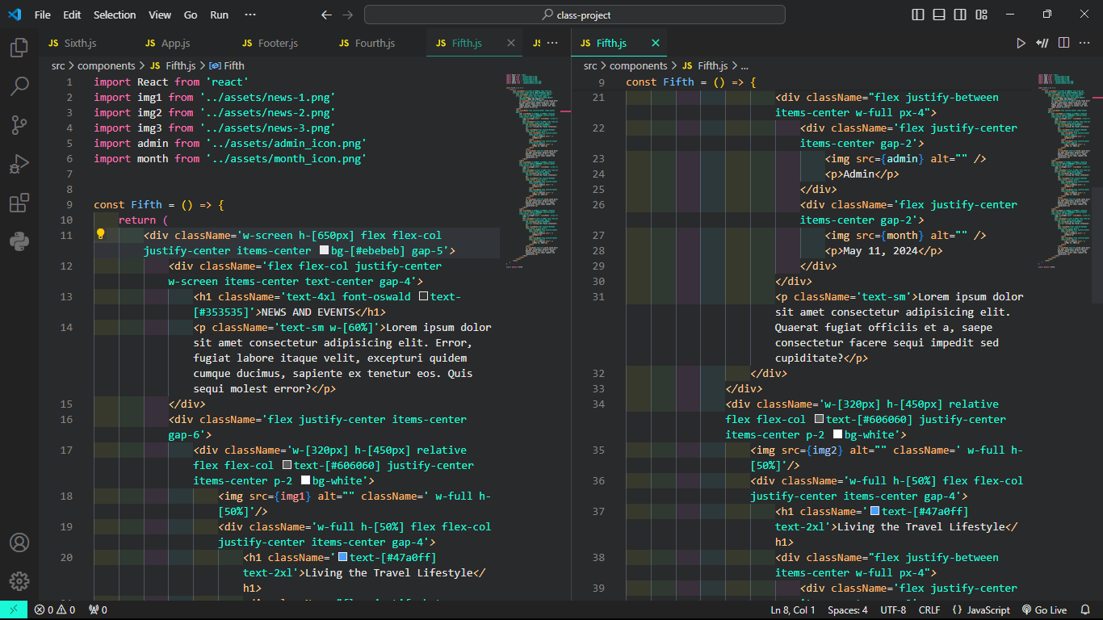

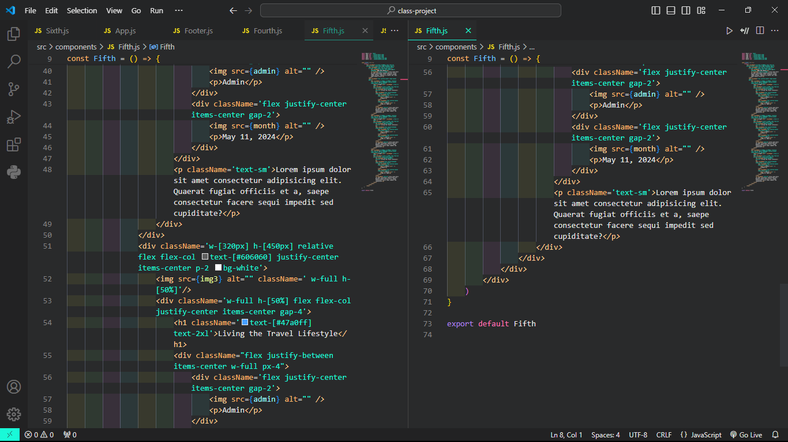

**Sixth.js:**

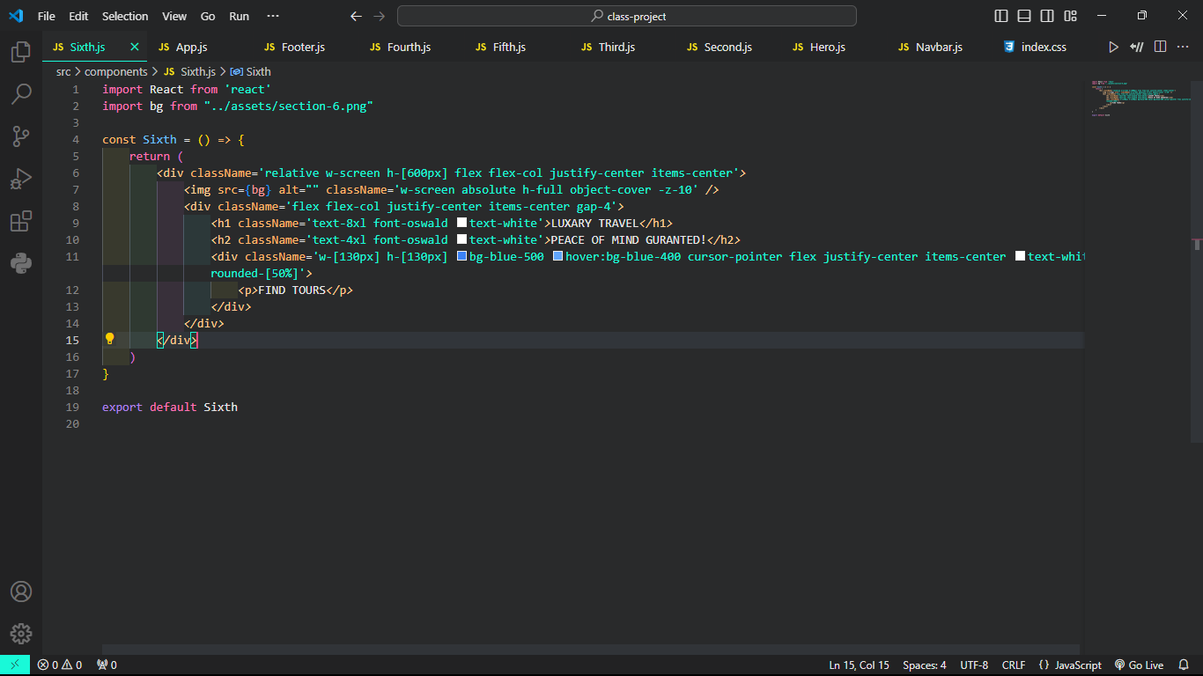

**Footer.js:**

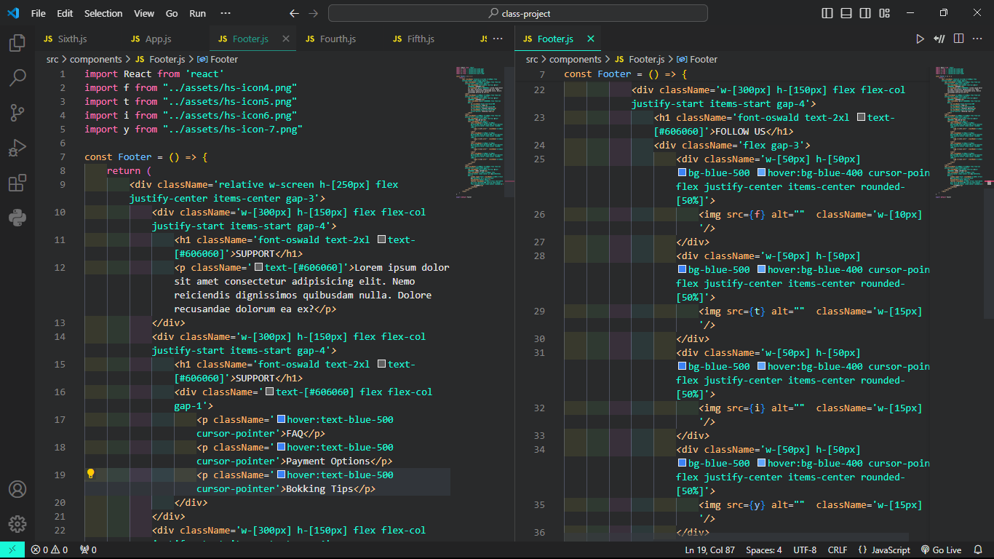

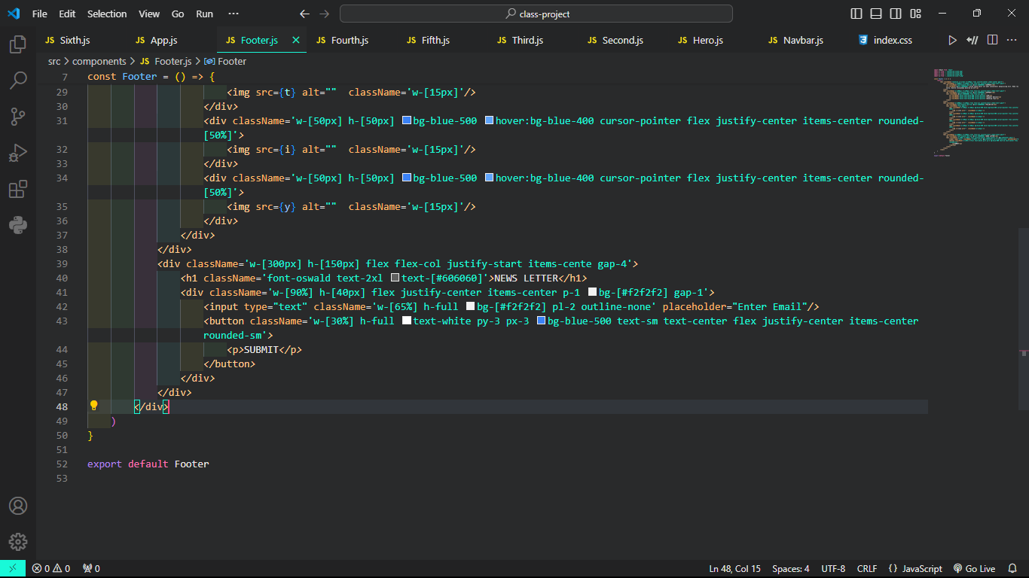

**Result:**

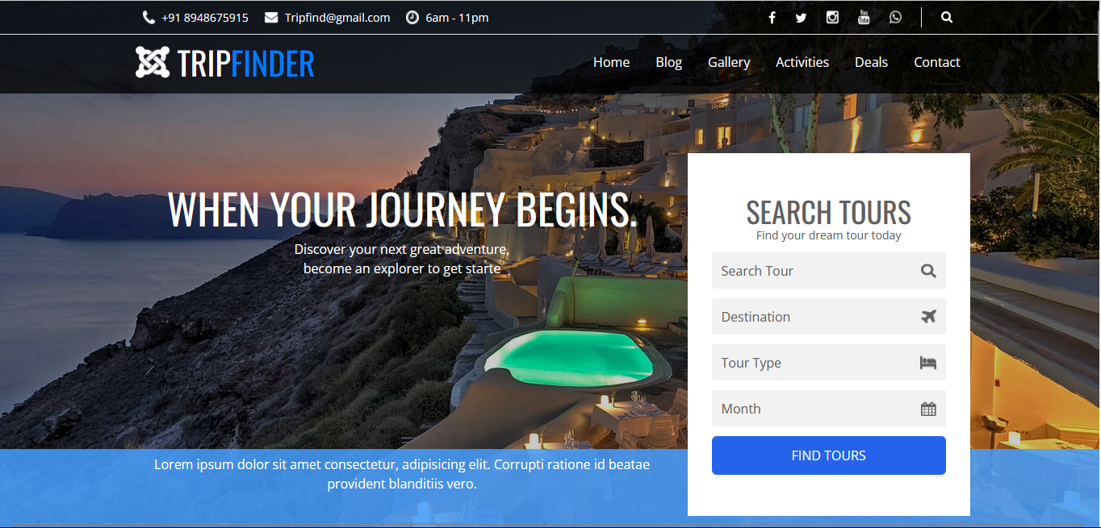

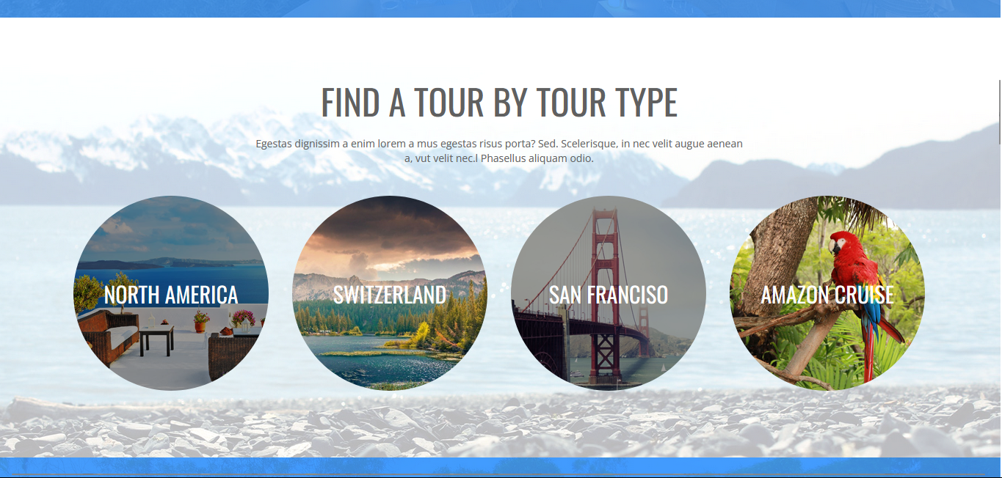

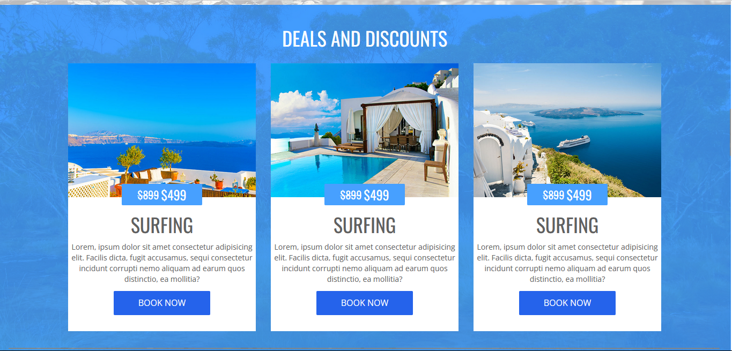

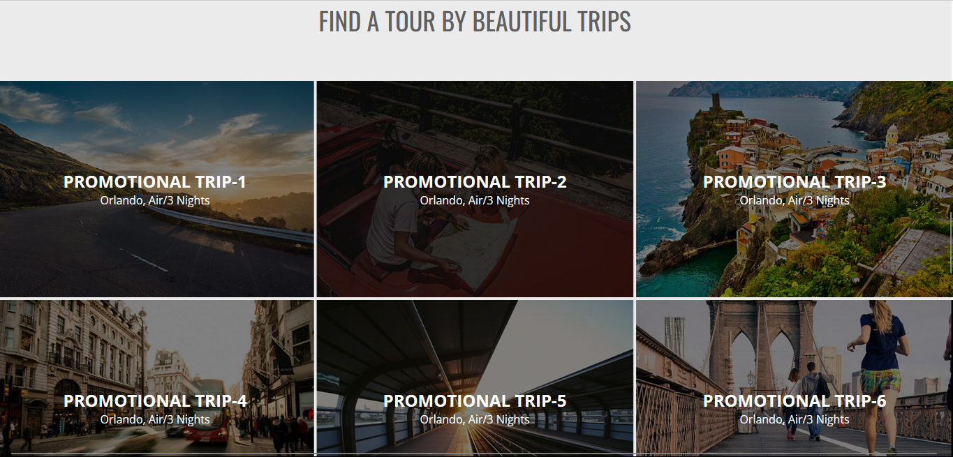

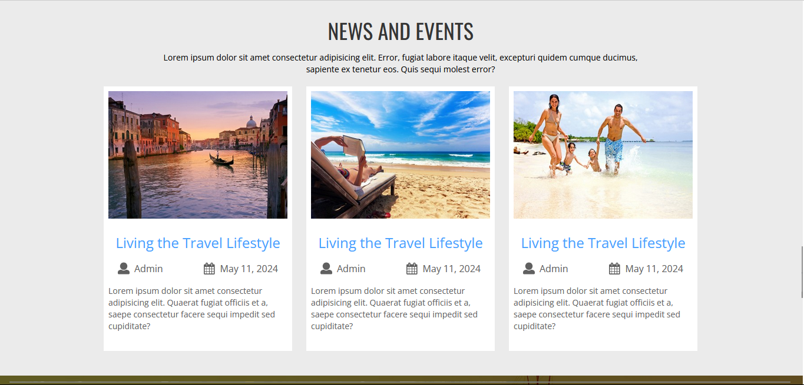

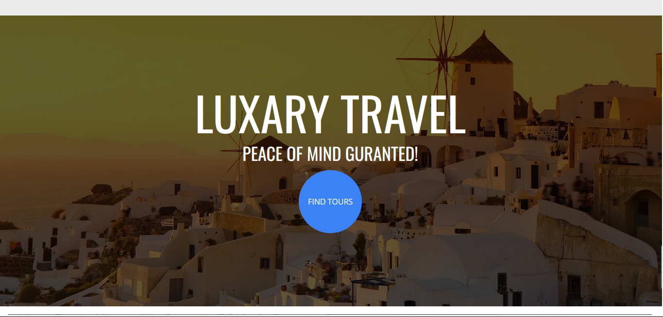

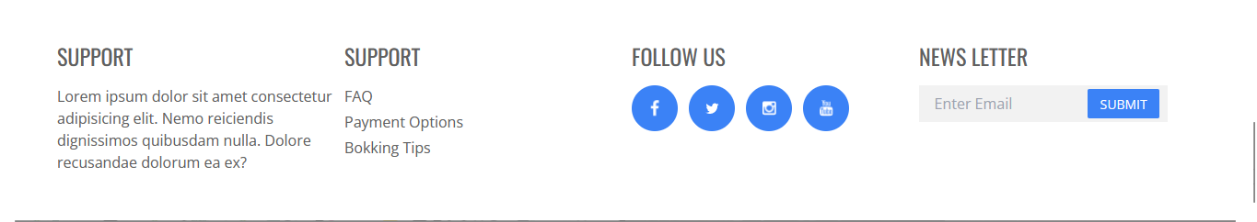

**Reference:**

**1.** [**https://www.photopea.com/**](https://www.photopea.com/)

**2.** [**https://fonts.google.com/**](https://fonts.google.com/)

**3.** [**https://tailwindcss.com/**](https://tailwindcss.com/)

**4.** [**https://legacy.reactjs.org/**](%20https:/legacy.reactjs.org/)